COURIER MANAGEMENT SYSTEM

Abstract:
The Courier Management System is a software application designed to manage and track courier services efficiently. The main objective of this system is to simplify the process of booking, tracking, and delivering parcels while maintaining accurate records. In traditional courier services, many tasks such as recording parcel details, tracking delivery status, and managing customer information are done manually, which can lead to errors and delays.
The proposed Courier Management System automates these activities by providing a centralized platform where users can enter courier details, track shipment status, and manage delivery information easily. The system allows administrators to store and update parcel information, customer details, and delivery records in a database. It also helps users track the current status of their courier using a tracking ID.

This system improves efficiency, reduces manual work, and ensures better accuracy in courier operations. It also enhances transparency by allowing real-time tracking and quick access to courier information. Overall, the Courier Management System helps courier service providers manage their operations more effectively and provide better service to customers.

1.INTRODUCTION:
Courier services play an important role in transporting packages and documents from one place to another. Managing courier details manually becomes difficult when the number of shipments increases.
The Courier Management System is designed to computerize courier operations. It helps in maintaining records of parcels, customers, and delivery details. The system makes it easier for administrators to manage courier services and for customers to track their shipments.
This system improves efficiency and ensures proper management of courier operations

2. Existing System:
The existing courier management system mainly depends on manual record keeping. Courier details such as sender information, receiver details, parcel information, and delivery status are written in registers or maintained in separate files.
Because of this manual process, many problems occur such as data redundancy, loss of records, and difficulty in tracking courier status. Searching for a particular courier record takes more time and effort.

Disadvantages of Existing System:
- Time consuming process
- High chance of human errors
- Difficult to maintain large records
- Courier tracking becomes difficult
- Data may be lost or damaged

3. Proposed System:
The proposed system introduces a computerized Courier Management System that stores all courier information in a digital database.
This system allows administrators to easily add, update, and delete courier records. Customers can track their courier using a unique tracking number. The system also helps in managing sender and receiver details in an organized manner.

Advantages of Proposed System:
- Faster data processing
- Easy courier tracking
- Reduced manual work
- Better data security
- Efficient management of courier information

4. Objectives of the Project:
The main objectives of the Courier Management System are:
- To maintain courier details in a computerized system.
- To reduce manual work in courier management.
- To provide easy tracking of courier status.
- To store sender and receiver information safely.
- To improve efficiency and accuracy in courier services.

5. Scope of the Project:
The Courier Management System can be used in courier companies to manage their daily operations. The system allows users to:
- Add courier details.
- Track courier status.
- Manage sender and receiver information.
- Update delivery status.
This system can be used by courier offices to manage parcel delivery effectively.

6. System Architecture:
System architecture describes the overall structure of the Courier Management System and how different components interact with each other.
The system follows a three-tier architecture:

1. Presentation Layer
This layer provides the user interface through which users interact with the system. It includes web pages designed using ASP.NET where users can enter courier details, view reports, and track shipments.

2. Application Layer
This layer contains the business logic of the system. It processes user requests, validates input data, and communicates with the database.

3. Database Layer
This layer stores all the data related to courier services. It includes information such as sender details, receiver details, courier status, and delivery records stored in SQL Server.

7. Modules of the System:

1. Admin Module
The admin can manage the entire system. Admin can add courier details, update delivery status, and view courier records.

2. Courier Booking Module
This module allows the user to enter courier details such as sender name, receiver name, address, and parcel information.

3. Tracking Module
Users can track their courier using a tracking ID. The system displays the current delivery status.

4. Delivery Module
This module updates whether the courier is delivered or still in transit.

8. System Requirements:

Hardware Requirements
- Processor: Intel Core i3 or above
- RAM: 4 GB or above
- Hard Disk: 500 GB
- Keyboard and Mouse

Software Requirements
- Operating System: Windows 10 or above
- Front End: ASP.NET
- Back End: SQL Server
- Development Tool: Microsoft Visual Studio

9. Database Design:
- The database is used to store courier information. It helps in maintaining all records in an organized way.
- Sample Tables
1. Courier Table
Field Name | Data Type | Description
CourierID | Int | Unique courier number
SenderName | Varchar | Name of sender
ReceiverName | Varchar | Name of receiver
Address | Varchar | Delivery address
Status | Varchar | Courier status
2. Customer Table
Field Name | Data Type | Description
CustomerID | Int | Unique customer ID
Name | Varchar | Customer name
Phone | Varchar | Contact number
Address | Varchar | Customer address
10. Advantages of the System:
The Courier Management System offers several advantages over the traditional manual system.
- Easy storage and retrieval of courier information
- Faster processing of courier details
- Reduced paperwork and manual errors
- Accurate tracking of courier status
- Improved efficiency in courier operations
- Better customer service and satisfaction

11. Limitations of the System:
The system may have some limitations:
- Online features may not work without an internet connection
- There is a possibility of data loss if the system crashes
- Advanced tracking features may not be available
However, these limitations can be improved in future updates.

12.System Testing:
System testing is performed to ensure that the system works correctly without errors.
Testing helps to identify problems and fix them before the system is used in real environments.

Types of Testing
- Unit Testing
- Integration Testing
- System Testing
- User Acceptance Testing
Testing ensures that the courier management system performs all functions correctly.

13.Feasibility Study:
A feasibility study is conducted to determine whether the proposed project can be successfully implemented or not.

1. Technical Feasibility
Technical feasibility refers to the availability of technical resources required to develop the system. The required hardware and software resources are available for this project. Technologies such as ASP.NET and SQL Server can be used to easily develop and implement the Courier Management System.

2. Economic Feasibility
Economic feasibility refers to the cost involved in developing and maintaining the system. The cost of developing this system is relatively low. Compared to the manual system, this computerized system saves both time and effort, making it cost-effective.

3. Operational Feasibility
Operational feasibility refers to how easily the system can be used by the users. The Courier Management System is designed with a user-friendly interface so that employees and administrators can easily operate and manage the system.

14.Input Design:
Input design refers to designing the data that users need to enter into the system.
In the Courier Management System, users need to enter the following details:
- Sender Name
- Receiver Name
- Address
- Contact Number
- Parcel Details
- Tracking ID
The input forms are designed to be simple and easy to use so that users can enter information quickly and accurately.
15. Output Design:
Output design refers to the results or reports generated by the system after processing the input data.
In the Courier Management System, the outputs include:
- Courier status report
- Delivery confirmation
- Customer details
- Courier tracking information
These outputs help users easily view and understand the courier information

16.Data Flow Diagram (DFD):
A Data Flow Diagram shows how data flows within the system.

Level 0 DFD
In this level, the user enters courier details into the system. The system processes the data, stores it in the database, and displays the tracking information to the user.

Level 1 DFD
The system is divided into the following processes:
- Courier booking process
- Data storage in the database
- Courier tracking
- Delivery status update

17.ER Diagram (Entity Relationship):
An ER Diagram shows the entities in the system and the relationships between them.

Entities
- Admin
- Courier
- Customer
- Delivery

Relationships
- Admin manages courier details
- Customer sends courier
- Courier is delivered to the receiver

18.Security Features:
Data security is very important in the Courier Management System.
The system includes the following security features:
- Login authentication system
- Password protection
- Database backup
- Restricted access for users
These features help prevent unauthorized users from accessing the system.

19.System Implementation:
System implementation is the stage where the designed system is developed and put into operation. In the Courier Management System, implementation involves coding, database creation, and integrating different modules.
The system is developed using ASP.NET as the front-end technology and SQL Server as the back-end database. The implementation process includes designing web pages, connecting the database, and writing program logic for different modules such as courier booking, tracking, and delivery updates.
After the development process is completed, the system is tested to ensure that all features work correctly. Once testing is completed successfully, the system can be deployed and used by the organization.

20.Applications of Courier Management System:
The Courier Management System can be used in different areas such as:
- Courier service companies
- Postal service departments
- Logistics companies
- E-commerce delivery services
- Office document delivery services
This system helps organizations manage parcel delivery in an efficient manner.

21.User Interface Design:
The user interface is designed to be simple and user-friendly so that users can easily operate the system.
The main pages of the system include:
- Login Page
- Admin Dashboard
- Courier Booking Page
- Courier Tracking Page
- Delivery Status Update Page
- Report Page
Each page provides easy navigation and allows users to perform tasks efficiently.

22.Reports Generated by the System:
The Courier Management System generates different types of reports to help administrators manage courier operations.

Types of Reports:
- Courier booking report
- Delivered courier report
- Pending courier report
- Customer details report
- Daily courier activity report
These reports help administrators analyze courier operations and improve service efficiency.
23.OUTPUT
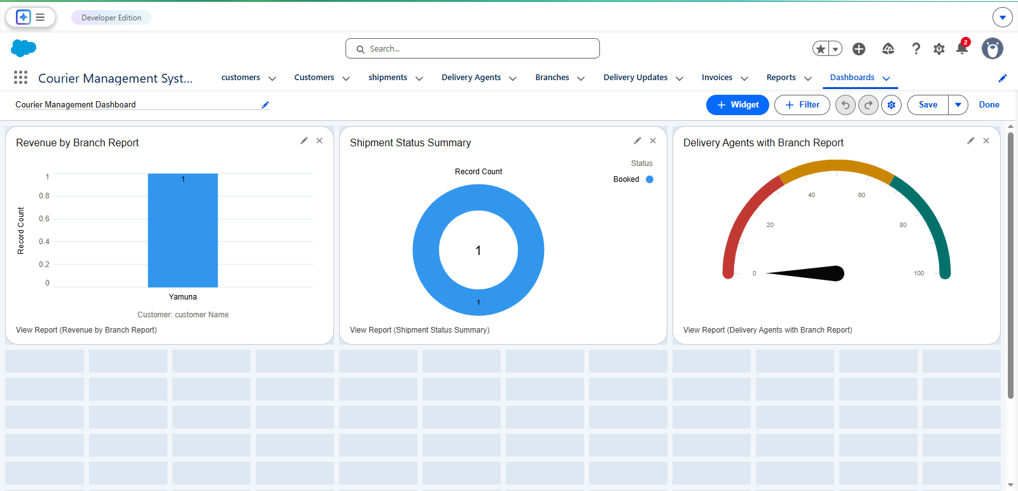
REFERNCE LINK
https://creative-goat-airbqi-dev-ed.trailblaze.lightning.force.com/lightning/r/Dashboard/01ZdM0000091GAPUA2/edit?navigationLocation=LIST_VIEW_ROW&layoutType=FULL

24.Future Enhancements:
The system can be improved in the future by adding more advanced features such as:
- Online courier booking
- SMS or email notification for courier status
- Mobile application for courier tracking
- GPS tracking for delivery vehicles
These improvements will make the system more efficient and user-friendly.
25.Conclusion:
The Courier Management System is developed to simplify and improve the process of managing courier services. This system helps in maintaining courier records, tracking parcel delivery, and managing sender and receiver information efficiently. By replacing the traditional manual system with a computerized system, the chances of errors are reduced and data can be stored safely.
The system provides a user-friendly interface that allows administrators to easily add, update, and manage courier details. It also helps users track the status of their parcels using a tracking ID. Overall, the Courier Management System increases efficiency, saves time, and improves the quality of courier service management.

26.Bibliography:
The following sources were referred to while developing the Courier Management System project.
- Pressman, R.S., Software Engineering: A Practitioner's Approach
- ASP.NET Official Documentation
- Microsoft SQL Server Documentation
- Online programming tutorials and educational websites

27.References:
The following resources were referred to while developing this project:
- Software Engineering books and study materials
- ASP.NET official documentation
- Microsoft SQL Server documentation
- Online programming tutorials and learning resources
- Educational websites related to web development and database management
Website:
https://www.slideshare.net/slideshow/courier-management-system-project-report-pdf/269360275

